EZ Tracker

Technical Report

Ryan Maynard, Delroy Christie, Jonas Gamao

April 25, 2019



# 

# Declaration of Joint Authorship

We, Jonas Gamao, Ryan Maynard, Derloy Christie, confirm that this work submitted for assessment is our own, and is expressed in our own words. Any uses made within it of the works of any other author, in any form (ideas, equations, figures, texts, tables, programs), are properly acknowledged at the point of use. Individual contribution per group member is indicated in the Work Breakdown and Requirements section of this report. A list of the references used is included.

____________________

Jonas Gamao

____________________

Ryan Maynard

____________________

Delroy Christie

# Copy of the Approved Proposal

# Abstract

With today’s society being more concerned about physical health, it becomes increasingly important for technology to address these needs. Our fitness tracker pilot project aims to address this issue particularly for a specific demographic. Presently, the majority of fitness trackers are aimed toward a younger, active and technologically literate group. While effective, they fail to address the needs of our target population by overloading them with information, and complex interfaces. The purpose of this report will explain the details and methods that have gone into the development and creation of a pedometer based project. Consisting of three sensors – a capacitive touch, an accelerometer and magnetometer and OLED display - the EZ Tracker creates entry level health monitoring and statistics at a glance. By taking users physical data (i.e. weight, height, and age), combined with their steps determined by the accelerometer, the device can calculate and display an approximate caloric loss on the native Android application, as well as the OLED display. By combining these technologies and collaborating amongst the members at JRD Developers, EZ Tracker aims to help promote a robust, inexpensive, and simple to use platform for its users.

# Introduction

This report describes the Internet of Things project that focusses on a monitoring system that tracks users’ steps over a predetermined period. The device described in the project is designed to cater for a segment of the market that is often overlooked. It seeks to address the challenges the elderly experienced with using and navigating complicated applications to do simple tasks. The objective of this undertaking is to simplify the process of using a device to aid the elderly in their pursuit of better health. The product aims to reduce the complexities in navigating a device to obtain specific information. The introduction of this product is significant because it caters to a segment of the market that no other product addresses.

The information presented will be centered on how the application will be integrated with designated hardware, and how it will allow users to keep track of their daily, weekly, and monthly. It also presents information about the types of hardware used, the database for storing and retrieving data, and the application used for the manipulation of these. During the building of the Android application, difficulties arose in determining the information being using for the core operation of the project, as well as deciding the relevant information to display. This resulted in a previous version not meeting the scope of our goal, and thus being omitted.

Table of Contents

Declaration of Joint Authorship 1

Copy of the Approved Proposal 2

Abstract 3

Introduction 4

Table of Contents 5

List of Illustrations or Diagrams 8

Work Breakdown and Requirements 10

Software specifications 10

Application Specifications and Breakdown 10

Database Specifications and Breakdown 10

Hardware Specifications and Breakdown 11

Build Instructions 12

Budget and Parts 12

Assembly 12

Preparing the Pi 12

Breadboarding and prototyping 14

PCB Design 15

Soldering 16

Power Up 20

Unit Testing – LSM303 20

Unit Testing – MPR121 21

Unit Testing – 128x64 Monochrome LED 22

Production Testing 23

Overall Description 25

Product Perspective 25

Product Functions 25

User Classes and Characteristics 26

Operating Environment 26

Design and Implementation Constraints 27

User Documentation 27

Assumptions and Dependencies 27

Hardware Interfaces 28

Software Interfaces 28

Communications Interfaces 29

System Features 29

Simple Mode 29

Description and Priority 29

Stimulus/Response Sequences 30

Functional Requirements 30

Other Non-functional Requirements 30

Performance Requirements 30

Safety Requirements 31

Database corruption 31

Security Requirements 31

Software Quality Attributes 32

Business Rules 32

Conclusions 33

Recommendations 34

Bibliography 35

Appendices 36

Appendix A: Glossary 36

# List of Illustrations or Diagrams

A breakdown of our work schedule

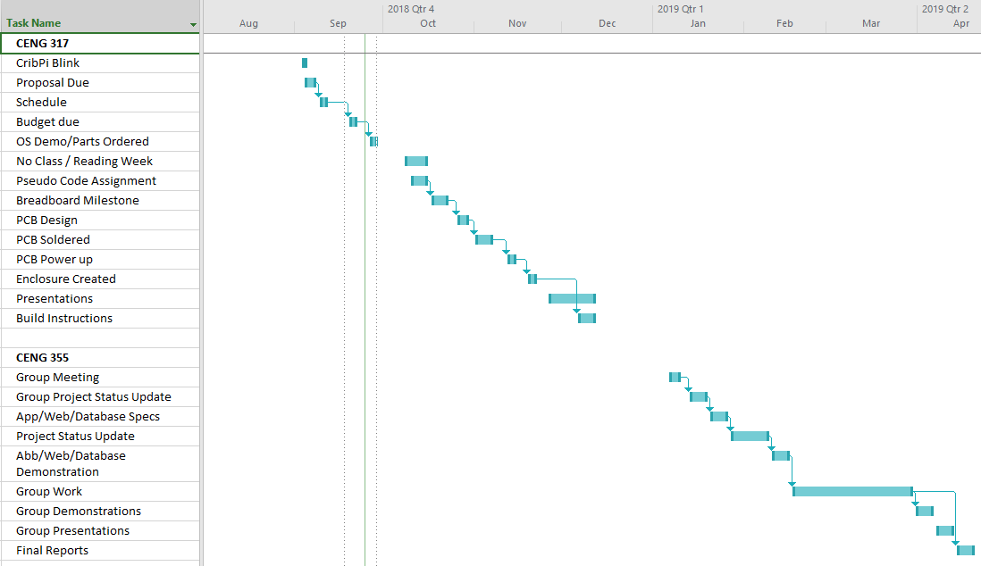

Although this project took us approximately fifteen week to complete, having all the parts in hand and following the included build instruction, it should take a person approximately one weekend to complete, provided he has a reasonable grasp of basic electronics and programming.

# Work Breakdown and Requirements

## Software specifications

### Application Specifications and Breakdown

Ryan will be responsible for refining and updating the current version of the Android application. He will update, modify, and adhere to new ideas of the project based on weekly meetings and discussions. Extensive testing will be performed on a number of devices owned by members of the group. Both Delroy and Ryan will jointly be responsible for creating a basic website that will read the raw data from the database. They will also be responsible for refining the site with advance data and metrics which will provide further detail not available on the Android application regarding statistics and hardware data, if possible.

### Database Specifications and Breakdown

The application will be collecting the data and send the results to Google’s Firebase. While the person is using the EZ Tracker hardware, it will not be connected to the internet. After doing extensive research on various ways of utilizing Firebase, saving a limited amount of data offline is something Firebase is capable of doing, which will be sent to the cloud when the device has connected to the internet. Jonas will be responsible for getting the EZ Tracker hardware to connect to the database, and the device connecting to the Android phone. Jonas will also be responsible in getting connectivity from the Broadcom development platform to the database. Jonas will also report if any additional information will be needed, created, and added to the database. The database will be implemented with constraints that will prohibit others users from reading and or access unauthorized user data. Other rules will be implemented as needed throughout the project.

### Hardware Specifications and Breakdown

The continual development of our Broadcom Development Platform, the Raspberry Pi, will be a combined effort amongst JRD Developers. In order to progress the project, the sensors must first be combined to a single entity that must be recognized on a sole system. JRD Developers will collaborate to create a new PCB on Fritzing that will enable the Pi to work with multiple sensors on a single board. Jonas will be responsible for connecting and testing the hardware components. Delroy will assist Jonas in the SSD1306 OLED display that will read the values from LSM303 Accelerometer and Magnetometer. Jonas will be held accountable for the capacitive touch sensor which will allow the user to control the device. Functionality will include changing what’s being shown on the display, starting, stopping, and restarting the device. This will allow the user to see the data they want to see, especially due to the display being small in size. As the project nears the final stages, the device will have to be re-housed into a more robust, sleek, and compact design. Delroy will be in charge for the re-design and refinement of the case using Corel Draw, and working with the prototype lab for laser cutting. Jonas and Ryan will help with additional suggestions and ideas. The hardware needs to be suitable to be carried by a person over a lengthy period of time, whether by holding on to it, or strapping it onto themselves. Therefore, the device needs to be compact. Measurements and revisions will be made to allow the EZ Tracker to have a small of a footprint as possible.

# Build Instructions

## Budget and Parts

Firstly, a list of parts will be required in order to recreate this project. Below is price a breakdown of the prices and parts for each component used to get the project to completion. Spreadsheet with hyper links can be found at the [EZ Tracker Repository.](https://github.com/YamiYukiSenpai/EZTracker/blob/master/Documentation/EZ_Parts_Budget.xlsx)

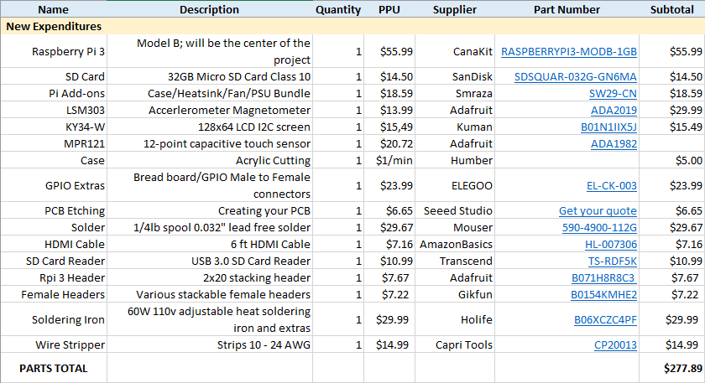

## Assembly

### Preparing the Pi

In this step we will cover basic Raspberry Pi imaging so you are able to login and access your device to test and drive your sensors. Download the latest [Raspberry Pi image](https://www.raspberrypi.org/downloads/). Our recommendation is NOOBS. This will ensure that starting off, you will have almost everything you need if you decide to re-purpose the device later on.

1. Download [etcher](https://www.balena.io/etcher/). This program will allow you to burn the Raspberry Pi image to your SD card.
2. Insert your SD card into the SD card reader and plug it into your computer.
3. Open etcher and follow the on screen instructions to burn your image. I found this program the easiest to use. [Extra documentation if needed](https://www.raspberrypi.org/documentation/installation/installing-images/README.md).
4. Insert the SD card into your Raspberry Pi along the underside of the device, logo facing out. Plug all of the required cables in such as: Ethernet, HDMI cable, mouse, keyboard, power, and turn the device on.
5. Upon boot you will see an option for different operating systems. Select **Raspbian** and follow the on screen instructions to complete the OS install.
6. At this point the Pi should boot to desktop. Follow the additional set up options on screen.
7. Enable I2C. This is the method we will be using to communicated with our Raspberry Pi. Type *sudo apt-get install -y python-smbus i2c-tools* into the terminal by pressing *ctrl+alt+t*.
8. Type *sudo raspi-config* into the terminal.
9. Go to interfacing options > and enable I2C.
10. Power down with *sudo powerdown* from the terminal by pressing and set the Pi aside. It will not be using it until sensor testing.

### Breadboarding and prototyping

Here we will cover basic sensor connectivity to the Raspberry Pi using a breadboard for creating mock layout/design that will be used in the PCB creation stage.

1. Gather the following items: Breadboard, LSM303 Sensor, MPR121, 128x64   
   LCD sensor, and 4 Female-to-Male GPIO cables.
2. Identify the labels on the sensor. For basic usage, we will be using: 3.3v, GND, SDA, and SCL.
3. Identify the corresponding pinouts on the Raspberry Pi. [This website is a great tool to use if you are unsure.](https://pinout.xyz/)
4. Plug in the female part of the GPIO cables into the Raspberry Pi’s 1,3,5, and 6 pins, based on the chart from pinout.xyz. These are the pins we are going to be using for this project.
5. Using the connectors that came with the sensors, plug them into the breadboard and rest the sensors accordingly. Below is an example.

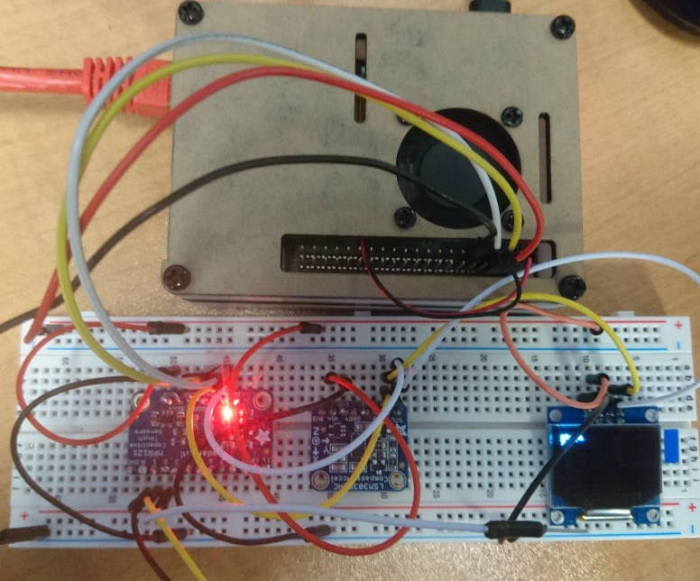

1. Connect the corresponding cables from the Raspberry Pi into the matched holes for the sensor.
2. (Optional but recommended) Power on the Raspberry Pi to see if the sensors are being detected correctly by viewing their address values.
3. (Optional but recommended) Open the terminal with *ctrl + alt + t* and run the command: *i2cdetect –y 1.* Ideally, the resulting output should be as follows, if not double check your connections and try again.

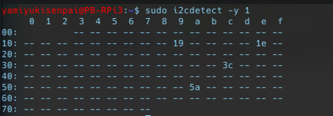

1. Voila! You have your mock up sensor connection!

### PCB Design

This is part of the project that needs to be proceeded with care and caution. It is advised to double check your designs before purchasing etching and cutting services. For this step, [Fritzing](http://fritzing.org/download/) will be used. It is an open-source application that allows the user to easily create PCB schematics for different development platforms. It is highly customizable and easy to use.

1. [Download](http://fritzing.org/download/) and extract Fritzing. Installation notes are on the linked page for various operating systems.
2. (Optional) Download the [AdaFruit Fritzing Library.](https://github.com/adafruit/Fritzing-Library) Handy if you want to take the extra step and create a mock or your own connection/designs in Fritzing.
3. Download our Fritzing file [here](https://github.com/YamiYukiSenpai/EZTracker/blob/master/pcb%20files/ez_v1.fzz) and open it. From the PCB tab, you can make changes at your leisure and pick it apart to see how it was made. Below is an image of our design.

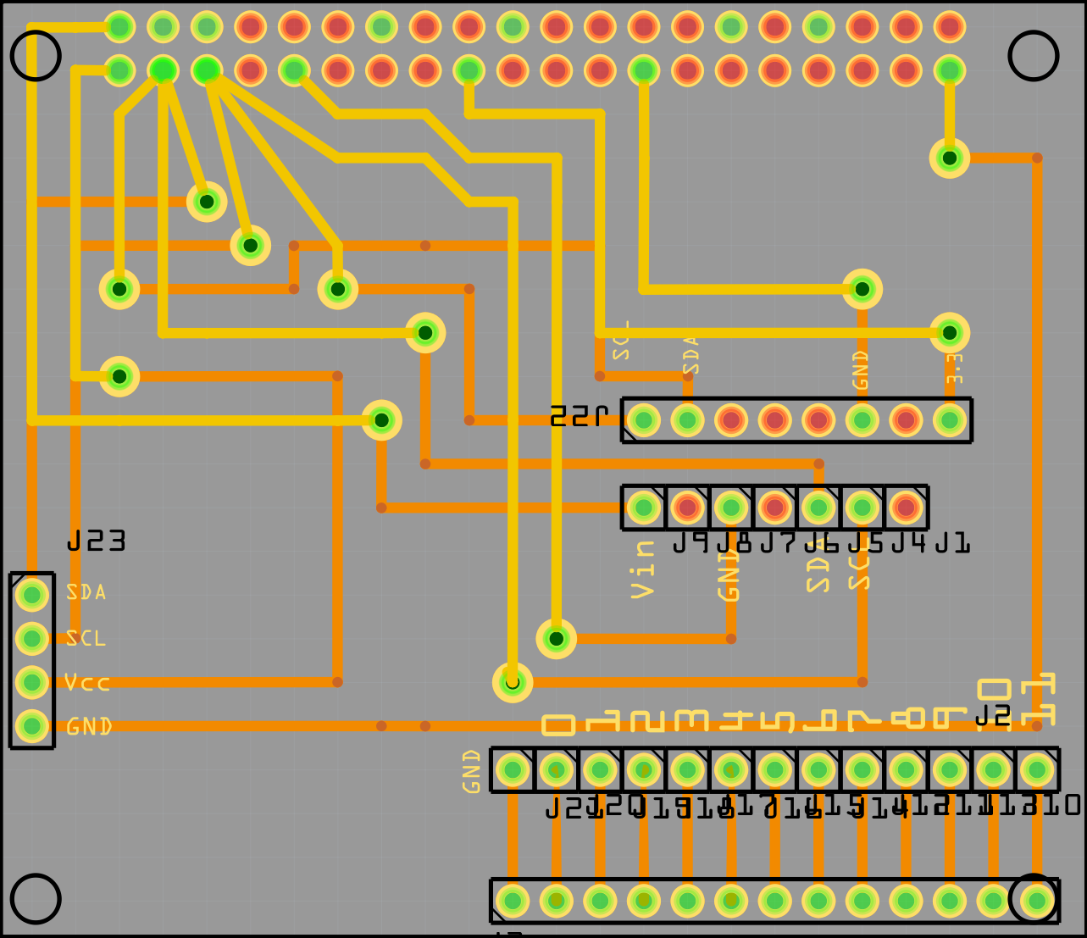

1. Export as a gerber file (the format primarily used in create a physical PCB). *File > Export for Production > Extended Gerber* and select an appropriate folder.
2. Zip/Compress the folder containing the gerber files and send them to your etcher of choice.

### Soldering

Once you have your PCB etched, we are ready to solder the parts together. Again, please double check your design before finally soldering.

1. Gather your sensors, copper wire, wire stripper, the pin headers that came with the sensor, your PCB, solder, and soldering iron.

[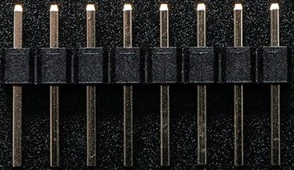](https://github.com/rfmaynard/Accel-MagnetoMeter/blob/master/images/8pin.png)

1. Solder your headers that came with your sensors, pictured above, to the corresponding holes. Put the longer end of the headers into your breadboard and place your sensor holes into the upright pins and solder all of the pins. This will ensure your sensor doesn’t move too much during soldering and a sturdy connection. **Note:** [Watch this video on soldering tips for additional help.](https://www.youtube.com/watch?v=oqV2xU1fee8) **Solder in a well ventilated area and use safety glasses.**

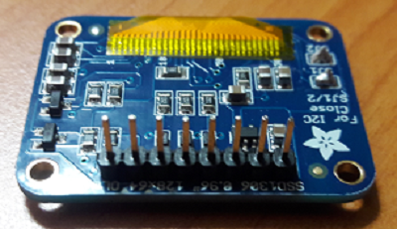

1. Solder your vias on your PCB. The easiest method I found, was to strip your copper wiring, stick it into the breadboard, and slide one via onto it so that it is flat and stable for soldering. Imaged below is an example, and repeat for each via. Once each via is soldered, snip the excess wire with cutters.

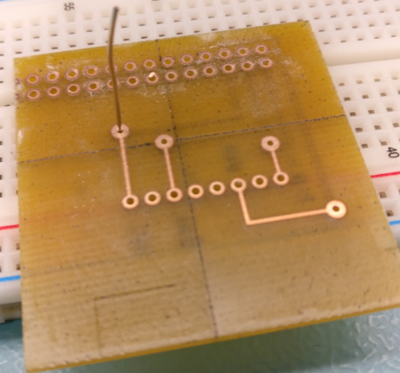

1. Solder your stackable headers. Using the breadboard again, take some extra copper wire from the snipped vias, or strip more, and place it into the female part of the header. The more, the sturdier. Flip the header over and plug it into the breadboard. Place your PCB onto the pins sticking out and solder the connections. Example placeholder image below.

[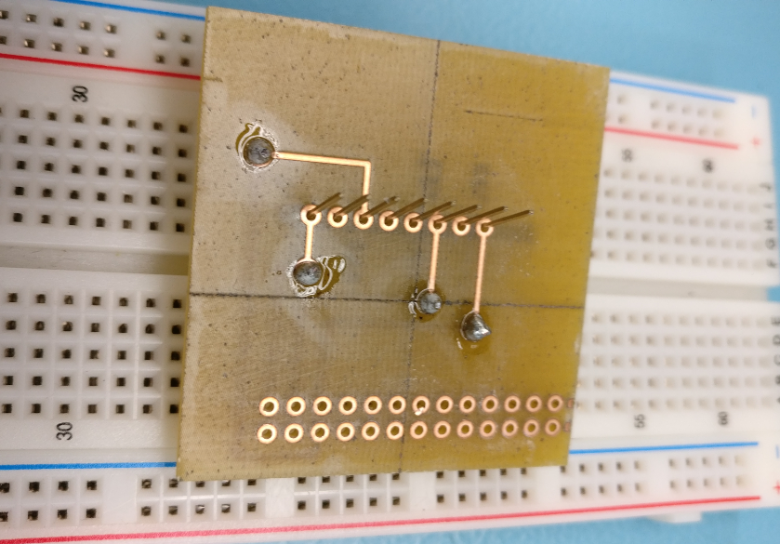](https://github.com/rfmaynard/Accel-MagnetoMeter/blob/master/images/PCBrotate.png)

1. Repeat the process for the 2x20 header for the Raspberry Pi. It’s not entirely necessary to solder all of the holes, but it ensures the PCB does not bend as much.
2. Your soldering should be complete. Plug everything in accordingly, and you should be ready for the next step! Example placeholder image below.

[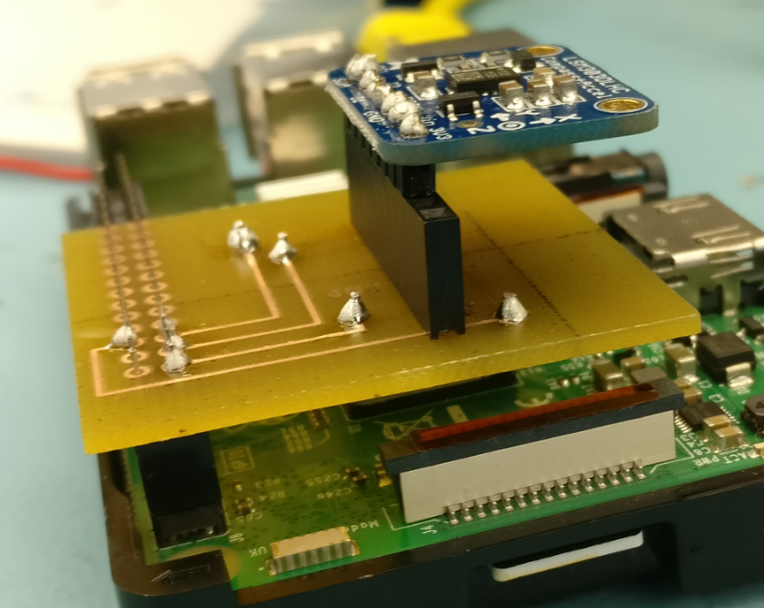](https://github.com/rfmaynard/Accel-MagnetoMeter/blob/master/images/PCBdone.png)

### **Power Up**

Once everything is plugged in, and you have double checked your connections, power on your Raspberry Pi.

1. Open up the terminal with *ctrl + alt + t* and run the command *i2cdetect – y 1*.
2. Hopefully everything is in working order. If so, you will see the following address values.



1. If not, go back and check if your sensors are connected accordingly.

### Unit Testing – LSM303

For this portion, you will need an internet connection as you will be required to download libraries in order to test each sensor.

1. Make sure your Pi is up to date with the latest packages. Run *sudo apt update* in the terminal to make sure everything is up to date.
2. We will be using Python to test the sensors, and will need the appropriate tools. Run the following commands in the terminal to ensure we have everything required to read from the sensor. We will test the LSM303 first.

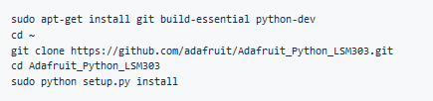

1. Navigate to the */Adafruit_Python_LSM303/examples* directory.
2. Test your sensor by running *python simpletest.py*. Your readings should look like the following:

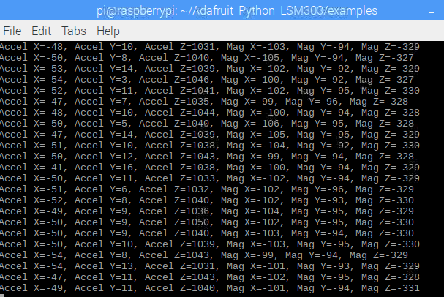

1. You can test the readings by moving your device in different directions with different speeds. You will notice the values changing accordingly.

### Unit Testing – MPR121

1. Download the test code from Jonas’s repository with: *wget* [*https://raw.githubusercontent.com/YamiYukiSenpai/MacroKeyTouchSensor/master/cap-touch.py*](https://raw.githubusercontent.com/YamiYukiSenpai/MacroKeyTouchSensor/master/cap-touch.py).
2. Run the code using *python cap-touch.py*. You will then be able to touch each of the nodes on the sensor, or you can have individual wires running from each position. Below is an example output.

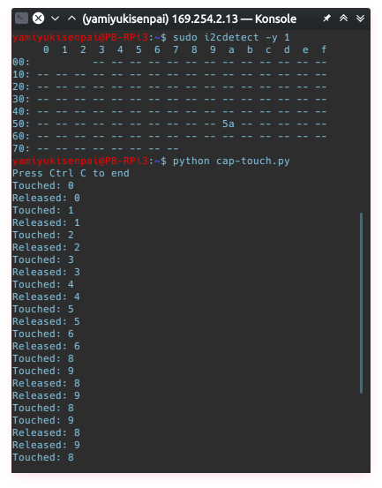

### Unit Testing – 128x64 Monochrome LED

1. Download the test code using *git clone https://github.com/adafruit/Adafruit_Python_SSD1306.git*
2. Navigate to the *Adafruit_Python_SSD1306/examples* directory and run the example code using *sudo python shapes.py*. The following should look like the placeholder image below.

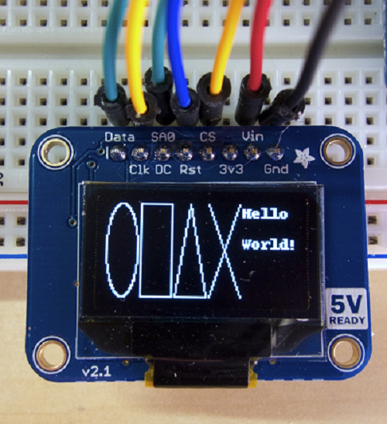

### Production Testing

[I have provided a case file](https://github.com/rfmaynard/Accel-MagnetoMeter/blob/master/case%20files/easeOmeter_CaseFiles_v4.cdr) (Created with CorelDraw x6) for those that wish to continue further for potential real world use. This case will ensure your sensors, Pi, and PCB are protected all while providing enough room for you to remove the sensor at your leisure. For portability, there is definite room that can be improved upon if you wish to make the device smaller and more portable. This concludes the end of the build instructions, and below is a placeholder image regarding the final product.

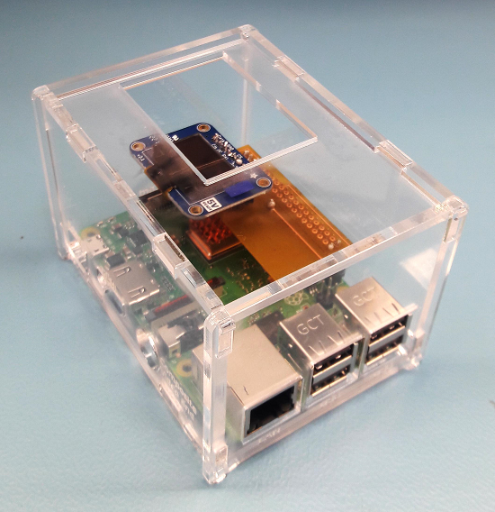

# Overall Description

## Product Perspective

This product was developed out of a specific need of the market. It is a new, self-contained product, the first version in its family. Its goal is to compete against fitness trackers that simply aim to add loads of features just to make them look like they are improving, but as in effect making them more and more complex.

## Product Functions

The application has five major functions. These include multiple modes, step counting, calorie tracking, speed, and goals. The multiple modes give the user the choice of how much data is presented to them. For example, the simple mode presents information in an easy-to-read text format with one graph or chart, depending on the information that the user selects. The advanced mode presents information in compact format with multiple graphs and charts. The step counting function is a feature that will count the number of steps a user has done. It can be turned on or off, depending on the activity (i.e, turned off for cycling)

* **Calorie tracking:** a function to calculate the calories burned based on distance traveled and steps taken.
* **Speed:** the feature where the speed at which the user traveled to accomplish his specific goal is calculated.
* **Goals:** users will be able to set goals for themselves for the week, and will be able to monitor said goal with ease in a simple, plain format.

## User Classes and Characteristics

* Elderly
  + Simple interface allowing for easy use
  + Large font options for readability
  + Most important user class due to the rising elderly population and with health/fitness on the minds of most people.
* Power Users
  + Advanced interface available for the tech-savvy users.
  + Detailed statistics for the avid health tracking user.
* Cyclists
  + Robust hardware allows user to never have to take out his/her phone while cycling.
  + Can monitor basic data on the built-in display.

## Operating Environment

The software will operate in conjunction with a Broadcom development platform (Raspberry Pi) as the main engine, a capacitive touch sensor/effector, an accelerometer, and an OLED monochrome display; powered by the Android 5.0 and above operating system as the mobile client. On the back end, the system will be linked to Linux based web server and Google’s Firebase database for data storage and retrieval.

## Design and Implementation Constraints

The program will be created using the Java programming language with Android libraries. Any smartphone that is capable of running Android 5.0 Lollipop will be able to use this app.

The following constraints can pose a possible threat to the complete functionality of the system:

* Users API’s version may not be up-to-date to install the application
* Device may not have enough disk space for the installation (mobile app)
* Google play store may not be available in the user’s demographic location
* Other mobile constraints may prevent the installation of the app

## User Documentation

As the app is still in the development stages, all future documentation/instructions will be found at: <https://github.com/YamiYukiSenpai/EZ_Tracker/tree/master/documentation>

# Assumptions and Dependencies

While the system is fairly simple to use, the assumption can be made that the system may be affected due to certain situations. These include but are not limited to:

* Browser compatibility- the system might not be able to run an outdated browser. Thus, users a being recommended to have the most current version of the browser installed on their device.
* OS Compatibility- The system might not be able to operate on versions of Android that are older than Lollipop, which is deemed outdated by the developer.
* Internet connection not available.

For the system to be fully functional and effective, it will be dependent on the following:

* Internet Connection- wile internet access is not absolutely necessary for the system to function, it does require internet access at some point to interact and retrieve data from the database stored on a web server.

## Hardware Interfaces

The EZ Tracker app interacts with a few hardware components to accomplish its tasks. Firstly, system is powered by a Broadcom development platform (Raspberry Pi B+) as its main engine. It also uses a small 128x64 SSD1306 OLED Display for simple, on the fly, statistics. Tracking data is made possible by the LSM303 Accelerometer and Magnetometer, while the MPR121 12-Point Capacitive Touch Sensor offers seamless interaction between the system and the user. Data collected will be recorded to the Trackers local flash SD card storage, and the online database. This will be read to the small built-in screen as well as displayed into the EZ Tracker application. Supported Android devices include Android 5.0 and above.

## Software Interfaces

Connections for the EZ Tracker

* Database: Google’s Firebase will be used as the database. Used for storing tracking metrics such as direction, speed, steps, etc. Will only be an outbound connection.

Connections for the EZ Tracker application

* Database: Inbound communication from Firebase. Will display information into the application and display.
* Operating System: Internet Connection (HTTP) to send a request and receive e-mail notifications/instructions for password reset (SMTP).

## Communications Interfaces

EZ Tracker will employ communication through a number of interfaces. The first method being the database between the Tracker and the phone. The logs will be stored on the database from the Tracker and corresponding statistics from the database onto the app (via HTTP/Internet). Secondly, users will have their e-mails tied to their accounts on the app. This will allow email notifications to be received without storing any mobile number information (via SMTP). E-mail notifications can be disabled. A feedback form will also be available from the settings menu for users to contribute any feedback to the developers.

# System Features

## Simple Mode

### Description and Priority

This mode will be the main attraction point for the app. In general, users just want their product to work. It will display the simplest forms of data required to be considered a health tracker. At a glance, users will be able to see all of the information they need to.

Priority Level: High

Risk: 2

Cost: 2

## Stimulus/Response Sequences

Preconditions: The user is logged in and the device is connected to the tracker, and the app has not been changed to Advanced Mode.

1. User wishes to see their up to date tracker stats.
2. User opens EZ Tracker and the Simple Mode page is displayed (calories, steps, goals, etc.).
3. User is able to view the basic stats they want to see for their general health/activity.

# Functional Requirements

REQ-1: must download and install app from the Google Play Store.

REQ-2: Must be running android 5.0 with at least API 27 on mobile device

REQ-3: User must be registered and logged into the application

# Other Non-functional Requirements

# Performance Requirements

Upon opening the application on the device. The user will be able to see their up-to-date statistics within 5-10 seconds. The OLED display on the EZ Tracker will continuously update in real time since the numbers are local. In the case of querying the database, connection can depend on the users signal strength and will timeout if not successfully refreshed after 20 seconds.

# Safety Requirements

## Database corruption

The information in the database can be back up with the master-slave method in order for users to retain their data in case of data loss.

## Security Requirements

The mobility domain has a privacy sensitive nature, specifically with regards to the location tracking of users. In order to create a viable offering for the user we will build a simple, transparent system that can be understood and trusted by the people that are using it.

In order to build trust with the users of our system, the system shall make use of the following strategies:

* Anonymization & aggregation, so that information may be shared safely without disclosing personal information.
* Encryption, for all data that is privacy sensitive, but must be persisted on the server in order for basic functionality
* Open source / disclose security policies & practices
* Permit the use of anonymous avatars / aliases.
* Give control to end-users over private data (at least a delete private repository option)

# Software Quality Attributes

* **Usability:** checking that the system is easy to use and intuitive for the people not comfortable with current technology.
* **Maintainability:** any crashes regarding the app will prompt the user to send the crash report to the developers.

# Business Rules

Documents or other materials used for this project cannot be used for commercial purposes without the knowledge and consent of the developers.

# Conclusions

The conception of the EZ Tracker IoT project was developed to address a special existing need in the market, and particularly for a specific demographic. During the course of fifteen weeks, we have done extensive research, development, and unit testing to ensure the product is ready and suitable for refinement, production, and distribution. We believe that with the integration of these technologies and the careful collaboration among team members, we have achieved our objective of producing a robust, inexpensive, and simple to use product for our target demography.

# Recommendations

The following recommendations are made with respect to the use of the app and corresponding hardware for the best results:

-

# Bibliography

# Appendices

## Appendix A: Glossary

**APP –** Short form for application

**Database –** An organized collection of data, stored and accessed electronically.

**Android** – an operating system designed for mobile devices (i.e. cell phones, tablet computers) by Google, Inc.

**Android device** – any device running Android. In this document, synonymous to “smart phone running Android.”

**Operating System** – the software that supports a computer's basic functions, such as scheduling tasks, executing applications, and controlling peripherals.

**SSD1306 Monochrome OLED Display** – a small display, about 1" diagonal, but very readable due to its high contrast. This display is made of 128x64 individual white OLED pixels, each one is turned on or off by the controller chip.

**LSM303 Accelerometer and Magnetometer** – a small chip that can determine speed as well as direction (North, South, East, West)

.

**MPR121 12-Point Capacitive Touch Sensor** – a touch sensor that can handle up to 12 individual touch pads and can be implemented with nearly any microcontroller.

**SD Card** – Secure Digital card is a type of memory card typically used in digital cameras and other portable devices.

**HTTP** – Hypertext Transfer Protocol is the underlying protocol used by the World Wide Web and this protocol defines how messages are formatted and transmitted, and what actions Web servers and browsers should take in response to various commands

**SMTP** – Simple Mail Transfer Protocol is an Internet standard for electronic mail (email) transmission.

**Firebase** - a mobile and web application development platform developed by Firebase, Inc., then acquired by Google. This online platform stores for our app.